T.20 Limited Over competition
Summary 2009/10 Season
Canterbury was disappointing in both batting and bowling and was in negative ratio in all categories. They were
unable to score 200 in any inning and had the lowest average team score of 146.
They only had four individual scores over 50 and the eleven were scored against them.
They took a wicket every 31 runs and lost a wicket every 19 runs.
They scored at 7.61 runs/over and had 8.20 runs/over scored against them
They took a wicket every 22 balls and lost a wicket every 15 balls.
They had six fifty runs partnerships and eleven were scored against them.
They had a higher percentage of sixes hit compared to 2008/09 but less boundary fours were hit.

History
This competition began in the 2005/06 season with the 6 teams split into 2 pools of three, the winners of each pool playing
off in a final. In 2006/07 and 2007/08 a full round of five matches was played followed by a final. In 2008/09 seven rounds
of matches were played to be followed by a final which was cancelled due to heavy rain. In 2009/10 a full round of ten matches were played followed by a final.

1.
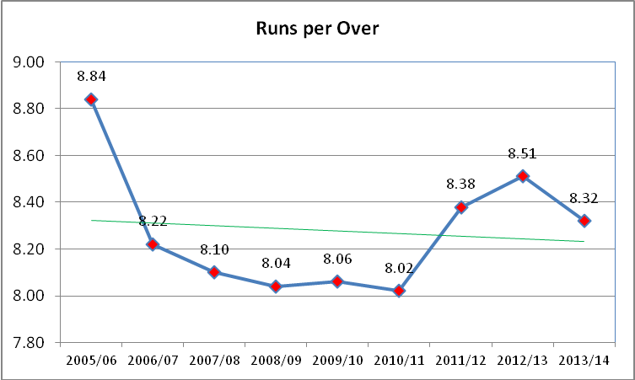

2.
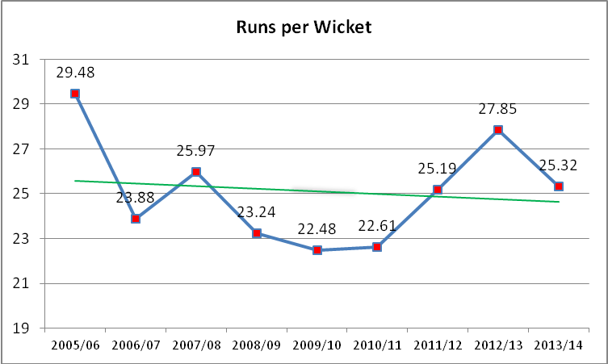
3.
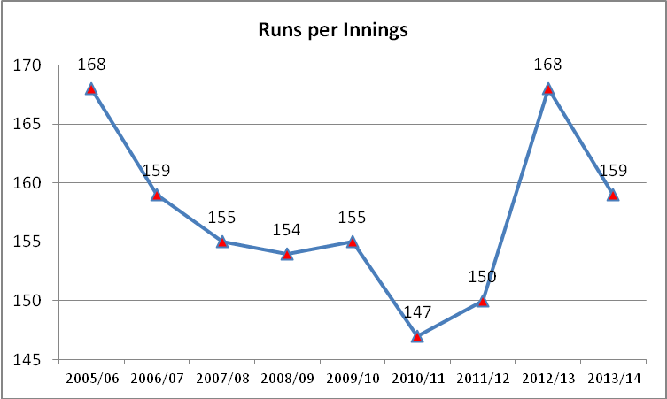

4.
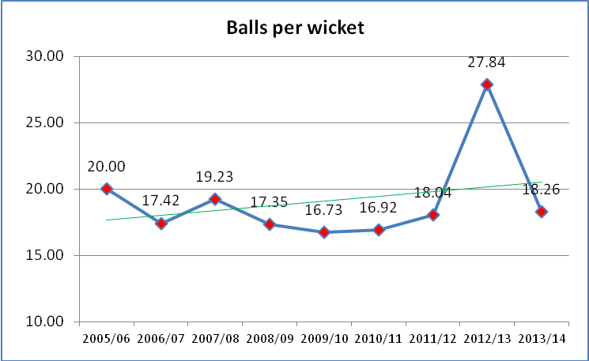

5,
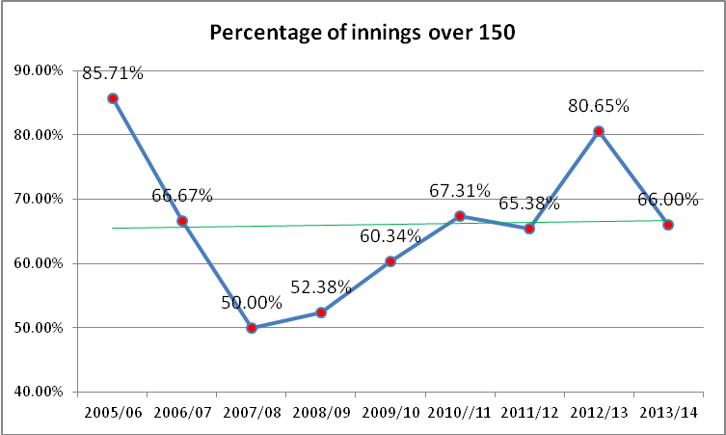

2008/09
Team | Inns | Runs | Balls | 150+ | 200+ | Wkts | Runs/Over | Runs/Wkt | Balls/Wkt | R/Inns | Position
Auckland | 7 | 1038 | 820 | 3 | 0 | 42 | 7.60 | 24.71 | 19.52 | 148 | 3
Canterbury | 7 | 1067 | 822 | 3 | 0 | 51 | 7.79 | 20.92 | 16.12 | 152 | 4
CD | 7 | 1067 | 775 | 4 | 0 | 50 | 8.26 | 21.34 | 15.50 | 152 | 1
ND | 7 | 1052 | 833 | 4 | 0 | 56 | 7.58 | 18.79 | 14.88 | 150 | 2
Otago | 7 | 1324 | 834 | 6 | 3 | 36 | 9.53 | 36.78 | 23.17 | 189 | 6
Wellington | 7 | 935 | 757 | 2 | 0 | 44 | 7.41 | 21.25 | 17.20 | 134 | 5
Total | 42 | 6483 | 4841 | 22 | 3 | 279 | 8.04 | 23.24 | 17.35 | 154

2009/10
Team | Inns |  |  | Runs |  | Balls |  | 150+ |  | 200+ |  | Wkts |  | Runs/Over |  | Runs/Wkt |  | Balls/Wkt |  | R/Inns |  | Position
Auckland | 11 |  |  | 1801 |  | 1277 |  | 8 |  | 1 |  | 72 |  | 8.46 |  | 25.01 |  | 17.74 |  | 164 |  | 2
Canterbury | 10 |  |  | 1464 |  | 1155 |  | 5 |  | 0 |  | 75 |  | 7.61 |  | 19.52 |  | 15.40 |  | 146 |  | 6
CD | 11 |  |  | 1679 |  | 1192 |  | 6 |  | 2 |  | 71 |  | 8.45 |  | 23.65 |  | 16.79 |  | 153 |  | 1
ND | 10 |  |  | 1525 |  | 1179 |  | 5 |  | 0 |  | 76 |  | 7.76 |  | 20.07 |  | 15.51 |  | 153 |  | 4
Otago | 8 |  |  | 1222 |  | 950 |  | 5 |  | 0 |  | 50 |  | 7.72 |  | 24.44 |  | 19.00 |  | 153 |  | 3
Wellington | 8 |  |  | 1300 |  | 937 |  | 6 |  | 1 |  | 56 |  | 8.32 |  | 23.21 |  | 16.73 |  | 163 |  | 5
Total | 58 |  |  | 8991 |  | 6690 |  | 35 |  | 4 |  | 400 |  | 8.06 |  | 22.48 |  | 16.73 |  | 155
2009/10
Team | Runs/wkt taken | Runs/Wkt lost |  | Team | Runs/Over for | Runs/Over against
Auckland | 21.91 | 25.01 |  | Auckland | 8.46 | 8.19
Canterbury | 31.33 | 19.52 |  | Canterbury | 7.61 | 8.20
CD | 21.08 | 23.65 |  | CD | 8.45 | 7.86
ND | 17.73 | 20.07 |  | ND | 7.76 | 7.52
Otago | 18.92 | 24.44 |  | Otago | 7.72 | 7.63
Wellington | 28.81 | 23.21 |  | Wellington | 8.32 | 9.09
Team | Balls/wkt taken | Balls/wkt lost
Auckland | 16.05 | 17.74
Canterbury | 22.92 | 15.40
CD | 16.09 | 16.79
ND | 14.14 | 15.51
Otago | 14.89 | 19
Wellington | 19.02 | 16.73

Individual Scores and Partnerships.

2005/06 |  |  |  |  |  | 2006/07
Team | 50 for | 50 agn | 50 part f | 50 part a |  | Team | 50 for | 50 agn | 50 part f | 50 part a
Auckland | 2 | 2 | 4 | 2 |  | Auckland | 5 | 5 | 7 | 8
Canterbury | 3 | 2 | 4 | 2 |  | Canterbury | 5 | 3 | 4 | 4
CD | 3 | 3 | 3 | 4 |  | CD | 3 | 5 | 4 | 3
ND | 2 |  | 1 | 3 |  | ND | 2 | 1 | 2 | 2
Otago | 2 | 2 | 2 | 2 |  | Otago | 1 | 4 | 3 | 3
Wellington |  | 3 | 1 | 2 |  | Wellington | 5 | 3 | 4 | 4
Total | 12 | 12 | 15 | 15 |  | Total | 21 | 21 | 24 | 24
2007/08 |  |  |  |  |  | 2008/09
Team | 50 for | 50 agn | 50 part f | 50 part a |  | Team | 50 for | 50 agn | 50 part f | 50 part a
Auckland | 4 | 1 | 3 | 5 |  | Auckland | 4 | 4 | 5 | 5
Canterbury | 1 |  | 2 | 2 |  | Canterbury | 2 | 5 | 6 | 6
CD | 4 | 4 | 6 | 3 |  | CD | 6 | 6 | 5 | 9
ND | 1 | 3 | 5 | 6 |  | ND | 3 | 4 | 3 | 6
Otago | 1 | 1 | 4 | 2 |  | Otago | 8 | 5 | 10 | 6
Wellington | 2 | 4 | 3 | 5 |  | Wellington | 3 | 2 | 5 | 2
Total | 13 | 13 | 23 | 23 |  | Total | 26 | 26 | 34 | 34
2009/10 |  |  |  |  |  | Five years
Team | 50 for | 50 agn | 50 part f | 50 part a |  | Team | 50 for | 50 agn | 50 part f | 50 part a
Auckland | 12 | 11 | 9 | 9 |  | Auckland | 27 | 23 | 28 | 29
Canterbury | 4 | 10 | 6 | 11 |  | Canterbury | 15 | 20 | 22 | 25
CD | 11 | 6 | 8 | 7 |  | CD | 27 | 24 | 26 | 26
ND | 5 | 4 | 6 | 3 |  | ND | 13 | 12 | 17 | 20
Otago | 6 | 4 | 8 | 2 |  | Otago | 18 | 16 | 27 | 15
Wellington | 6 | 9 | 5 | 10 |  | Wellington | 16 | 21 | 18 | 23
Total | 44 | 44 | 42 | 42 |  | Total | 116 | 116 | 138 | 138
Auckland and Central Districts are the stand out teams over the five years of competition with Otago having
by a considerable margin the best for and against 50 run partnership ratio.

Boundaries Team Comparison

2008/09
Team | Runs | Fours | Total fours | Four % | Team | Runs | Sixes | Total sixes | Sixes %
Wellington | 935 | 83 | 332 | 35.51% | Otago | 1324 | 66 | 396 | 29.91%
Canterbury | 1067 | 86 | 344 | 32.24% | Auckland | 1038 | 42 | 252 | 24.28%
ND | 1052 | 83 | 332 | 31.56% | CD | 1067 | 38 | 228 | 21.37%
CD | 1067 | 84 | 336 | 31.49% | Canterbury | 1067 | 32 | 192 | 17.99%
Otago | 1324 | 100 | 400 | 30.21% | ND | 1052 | 31 | 186 | 17.68%
Auckland | 1038 | 77 | 308 | 29.67% | Wellington | 935 | 24 | 144 | 15.40%
 | 6483 | 513 | 2052 | 31.65% |  | 6483 | 233 | 1398 | 21.56%
2009/10
Team | Runs | Fours | Total fours | Four % | Team | Runs | Sixes | Total sixes | Sixes %
ND | 1525 | 128 | 512 | 33.57% | Wellington | 1300 | 56 | 336 | 25.85%
Otago | 1222 | 87 | 348 | 28.48% | Otago | 1222 | 47 | 282 | 23.08%
Auckland | 1801 | 125 | 500 | 27.76% | Canterbury | 1464 | 55 | 330 | 22.54%
Canterbury | 1464 | 101 | 404 | 27.60% | Auckland | 1801 | 61 | 366 | 20.32%
Wellington | 1300 | 86 | 344 | 26.46% | CD | 1679 | 55 | 330 | 19.65%
CD | 1679 | 84 | 336 | 20.01% | ND | 1525 | 44 | 264 | 17.31%
 | 8991 | 611 | 2444 | 27.18% |  | 8991 | 318 | 1908 | 21.22%

The interesting point here is that the percentage of boundaries four is lower this past season compared to 2008/09 but the percentage of sixes remains similar at 21%. Northern has the greatest difference scoring high in boundaries fours but comes
last in the number of sixes hit.

Team Scores Over 150: 200
150+ 200+
2005/06 12 out of 14 ins (85.7%) 2 out of 14 ins (14.2%)
2006/07 20 out of 30 ins (66.6%) 2 out of 30 ins (6.6%)
2007/08 16 out of 32 ins (50.0%) 1 out of 32 ins (3.1%)
2008/09 22 out of 42 ins (52.3%) 3 out of 42 ins (7.1%)
2009/10 35 out of 58 ins (60.3%) 4 out of 58 ins (6.9%)

Difficult to make valid comparisons due to the fewer matches played in the first year of the competition but the
2009/10 season’s results show an increase in scores over 150.

Home and Away Results
2005/06 | C |  |  | ND |  |  | W |  |  | O |  |  | CD |  |  | A
 | Win | Loss |  | Win | Loss |  | Win | Loss |  | Win | Loss |  | Win | Loss |  | Win | Loss |  | Win | Loss
Home | 1 |  |  |  | 1 |  |  | 1 |  |  | 1 |  |  | 1 |  | 1 | 1 |  | 2 | 5
Away | 2 |  |  | 1 |  |  |  | 1 |  |  | 1 |  | 1 |  |  | 1 |  |  | 5 | 2
Total | 3 |  |  | 1 | 1 |  |  | 2 |  |  | 2 |  | 1 | 1 |  | 2 | 1 |  | 7 | 7
2006/7 | C |  |  | ND |  |  | W |  |  | O |  |  | CD |  |  | A
 | Win | Loss |  | Win | Loss |  | Win | Loss |  | Win | Loss |  | Win | Loss |  | Win | Loss |  | Win | Loss
Home | 1 | 1 |  | 1 | 2 |  | 2 |  |  | 1 | 1 |  | 1 | 1 |  | 3 | 1 |  | 9 | 6
Away | 2 | 1 |  |  | 2 |  |  | 2 |  | 2 | 1 |  |  | 3 |  | 2 |  |  | 6 | 9
Total | 3 | 2 |  | 1 | 4 |  | 2 | 2 |  | 3 | 2 |  | 1 | 4 |  | 5 | 1 |  | 15 | 15
2007/08 | C |  |  | ND |  |  | W |  |  | O |  |  | CD |  |  | A
 | Win | Loss |  | Win | Loss |  | Win | Loss |  | Win | Loss |  | Win | Loss |  | Win | Loss |  | Win | Loss
Home | 1 | 1 |  | 3 |  |  | 2 | 1 |  | 1 | 1 |  | 2 | 1 |  | 2 | 1 |  | 11 | 5
Away | 2 | 1 |  |  | 3 |  |  | 2 |  |  | 3 |  | 2 | 1 |  | 1 | 1 |  | 5 | 11
Total | 3 | 2 |  | 3 | 3 |  | 2 | 3 |  | 1 | 4 |  | 4 | 2 |  | 3 | 2 |  | 16 | 16
2008/09 | C |  |  | ND |  |  | W |  |  | O |  |  | CD |  |  | A
 | Win | Loss |  | Win | Loss |  | Win | Loss |  | Win | Loss |  | Win | Loss |  | Win | Loss |  | Win | Loss
Home | 2 | 1 |  |  | 3 |  | 1 | 2 |  | 3 | 1 |  |  | 4 |  | 2 | 2 |  | 8 | 13
Away | 3 | 1 |  |  | 4 |  | 3 | 1 |  | 3 |  |  | 1 | 2 |  | 3 |  |  | 13 | 8
Total | 5 | 2 |  | 0 | 7 |  | 4 | 3 |  | 6 | 1 |  | 1 | 6 |  | 5 | 2 |  | 21 | 21
2009/10 | C |  |  | ND |  |  | W |  |  | O |  |  | CD |  |  | A
 | Win | Loss |  | Win | Loss |  | Win | Loss |  | Win | Loss |  | Win | Loss |  | Win | Loss |  | Win | Loss
Home |  | 5 |  | 3 | 2 |  | 2 | 2 |  | 2 | 2 |  | 5 | 1 |  | 3 | 1 |  | 15 | 13 | 1 tie
Away | 2 | 3 |  | 2 | 3 |  | 1 | 3 |  | 2 | 1 |  | 3 | 2 |  | 3 | 3 |  | 13 | 15
Total | 2 | 8 |  | 5 | 5 |  | 3 | 5 |  | 4 | 3 |  | 8 | 3 |  | 6 | 4 |  | 28 | 28
5 years | C |  |  | ND |  |  | W |  |  | O |  |  | CD |  |  | A
 | Win | Loss |  | Win | Loss |  | Win | Loss |  | Win | Loss |  | Win | Loss |  | Win | Loss |  | Win | Loss
Home | 5 | 8 |  | 7 | 8 |  | 7 | 6 |  | 7 | 6 |  | 8 | 8 |  | 11 | 6 |  | 45 | 42
Away | 11 | 6 |  | 3 | 12 |  | 4 | 9 |  | 7 | 6 |  | 7 | 8 |  | 10 | 4 |  | 42 | 45
Total | 16 | 14 |  | 10 | 20 |  | 11 | 15 |  | 14 | 12 |  | 15 | 16 |  | 21 | 10 |  | 87 | 87
Over the five years very little difference in the overall results but Canterbury have more victories away while
Northern have more losses away.

Batting first - second.
2005/06 | C |  |  | ND |  |  | W |  |  | O |  |  | CD |  |  | A
 | Win | Loss |  | Win | Loss |  | Win | Loss |  | Win | Loss |  | Win | Loss |  | Win | Loss |  | Win | Loss
First |  |  |  |  | 1 |  |  | 2 |  |  | 2 |  |  | 1 |  |  | 1 |  |  | 7
Second | 3 |  |  | 1 |  |  |  |  |  |  |  |  | 1 |  |  | 2 |  |  | 7
Total | 3 |  |  | 1 | 1 |  |  | 2 |  |  | 2 |  | 1 | 1 |  | 2 | 1 |  | 7 | 7
2006/7 | C |  |  | ND |  |  | W |  |  | O |  |  | CD |  |  | A
 | Win | Loss |  | Win | Loss |  | Win | Loss |  | Win | Loss |  | Win | Loss |  | Win | Loss |  | Win | Loss
First | 1 |  |  | 1 | 2 |  |  | 2 |  | 3 | 1 |  | 1 | 1 |  | 3 |  |  | 9 | 6
Second | 2 | 2 |  |  | 2 |  | 2 |  |  |  | 1 |  |  | 3 |  | 2 | 1 |  | 6 | 9
Total | 3 | 2 |  | 1 | 4 |  | 2 | 2 |  | 3 | 2 |  | 1 | 4 |  | 5 | 1 |  | 15 | 15
2007/08 | C |  |  | ND |  |  | W |  |  | O |  |  | CD |  |  | A
 | Win | Loss |  | Win | Loss |  | Win | Loss |  | Win | Loss |  | Win | Loss |  | Win | Loss |  | Win | Loss
First | 2 | 1 |  |  | 1 |  |  | 2 |  | 1 | 3 |  | 2 | 1 |  | 1 | 2 |  | 6 | 10
Second | 1 | 1 |  | 3 | 2 |  | 2 | 1 |  |  | 1 |  | 2 | 1 |  | 2 | 0 |  | 10 | 6
Total | 3 | 2 |  | 3 | 3 |  | 2 | 3 |  | 1 | 4 |  | 4 | 2 |  | 3 | 2 |  | 16 | 16
2008/09 | C |  |  | ND |  |  | W |  |  | O |  |  | CD |  |  | A
 | Win | Loss |  | Win | Loss |  | Win | Loss |  | Win | Loss |  | Win | Loss |  | Win | Loss |  | Win | Loss
First | 2 | 1 |  |  | 4 |  | 1 | 2 |  | 5 |  |  | 1 | 3 |  | 1 | 1 |  | 10 | 11
Second | 3 | 1 |  |  | 3 |  | 3 | 1 |  | 1 | 1 |  |  | 3 |  | 4 | 1 |  | 11 | 10
Total | 5 | 2 |  | 0 | 7 |  | 4 | 3 |  | 6 | 1 |  | 1 | 6 |  | 5 | 2 |  | 21 | 21
2009/10 | C |  |  | ND |  |  | W |  |  | O |  |  | CD |  |  | A
 | Win | Loss |  | Win | Loss |  | Win | Loss |  | Win | Loss |  | Win | Loss |  | Win | Loss |  | Win | Loss
First |  | 5 |  | 3 | 2 |  | 2 | 1 |  | 2 | 2 |  | 4 | 1 |  | 4 | 2 |  | 15 | 13 | 1 tie
Second | 2 | 3 |  | 2 | 3 |  | 1 | 4 |  | 2 | 1 |  | 4 | 2 |  | 2 | 2 |  | 13 | 15
Total | 2 | 8 |  | 5 | 5 |  | 3 | 5 |  | 4 | 3 |  | 8 | 3 |  | 6 | 4 |  | 28 | 28
5 years | C |  |  | ND |  |  | W |  |  | O |  |  | CD |  |  | A
 | Win | Loss |  | Win | Loss |  | Win | Loss |  | Win | Loss |  | Win | Loss |  | Win | Loss |  | Win | Loss
First | 5 | 7 |  | 4 | 10 |  | 3 | 9 |  | 11 | 8 |  | 8 | 7 |  | 9 | 6 |  | 40 | 47 | 1 tie
Second | 11 | 7 |  | 6 | 10 |  | 8 | 6 |  | 3 | 4 |  | 7 | 9 |  | 12 | 4 |  | 47 | 40
Total | 16 | 14 |  | 10 | 20 |  | 11 | 15 |  | 14 | 12 |  | 15 | 16 |  | 21 | 10 |  | 87 | 87
Some significant results with Otago winning most of their matches by batting first. In contrast Canterbury has won most
of their matches batting second. Clearly a slight trend emerges that more success has been achieved batting second. Over
the five years 54% have been won batting second and 46% matches won batting first.

Toss Results
In 2005/06 the team winning the toss inserted the opposition (100%) and all matches were won batting second.
In 2006/07 the team winning the toss and inserting the opposition (46%) won three matches and lost four matches.
When the team won the toss and batted it won six matches and lost two matches.
In 2007/08 the team winning the toss and inserting the opposition (40%) won four matches and lost two matches.
When the team won the toss and batted it won four matches and lost five matches
In 2008/09 the team winning the toss and inserting the opposition (76%) won eight matches and lost eight matches.
When the team won the toss and batted it won two matches and lost three matches.
In 2009/10 the team winning the toss and inserting the opposition (68%) won eight matches and lost eleven matches.
When the team won the toss and batted it won four matches and lost five matches.

Over the five years the side winning the toss has inserted on 51 occasions, 63%.

20.20 Ground Results

2005/06 | Inns | Runs | 150-200 | 200+ | Bat 1st | Bat 2nd | Balls | Wkts | R/O | R/Wt | R/Inns
Basin Reserve | 2 | 371 | 2 |  |  | 1 | 238 | 13 | 9.35 | 28.54 | 186
Eden Outer | 4 | 669 | 4 |  |  | 2 | 463 | 23 | 8.67 | 29.09 | 167
Hagley Park | 2 | 310 | 2 |  |  | 1 | 220 | 12 | 8.45 | 25.83 | 155
Seddon Park | 2 | 226 |  |  |  | 1 | 207 | 11 | 6.55 | 20.55 | 113
McLean Park | 2 | 343 | 2 |  |  | 1 | 238 | 13 | 8.65 | 26.38 | 172
University Oval | 2 | 439 | 2 | 2 |  | 1 | 234 | 8 | 11.26 | 54.88 | 220
Total | 14 | 2358 | 12 | 2 |  | 7 | 1600 | 80 | 8.84 | 29.48 | 168
2006/07 | Inns | Runs | 150-200 | 200+ | Bat 1st | Bat 2nd | Balls | Wkts | R/O | R/Wt | R/Inns
Basin Reserve | 4 | 664 | 4 |  |  | 2 | 459 | 21 | 8.68 | 31.62 | 166
Cobham Oval | 2 | 248 |  |  | 1 |  | 240 | 12 | 6.20 | 20.67 | 124
Eden Outer | 8 | 1413 | 7 | 2 | 3 | 1 | 951 | 50 | 8.91 | 28.26 | 177
Seddon Park | 4 | 608 | 2 |  | 1 | 1 | 480 | 29 | 7.60 | 20.97 | 152
McLean Park | 2 | 288 | 1 |  | 1 |  | 234 | 19 | 7.38 | 15.16 | 144
New Plymouth | 2 | 284 | 1 |  | 1 |  | 212 | 19 | 8.04 | 14.95 | 142
University Oval | 4 | 550 | 1 |  | 1 | 1 | 440 | 34 | 7.50 | 16.18 | 138
Village Green | 4 | 720 | 4 |  | 1 | 1 | 468 | 16 | 9.23 | 45.00 | 180
Total | 30 | 4775 | 20 | 2 | 9 | 6 | 3484 | 200 | 8.22 | 23.88 | 159
2007/08 | Inns | Runs | 150-200 | 200+ | Bat 1st | Bat 2nd | Balls | Wkts | R/O | R/Wt | R/Inns
Basin Reserve | 6 | 899 | 2 | 1 | 1 | 2 | 686 | 30 | 7.86 | 29.97 | 150
Eden Outer | 6 | 1016 | 4 |  | 1 | 2 | 718 | 32 | 8.49 | 31.75 | 169
Seddon Park | 6 | 928 | 2 |  |  | 3 | 686 | 30 | 7.38 | 15.16 | 144
New Plymouth | 6 | 1008 | 4 |  |  | 3 | 654 | 39 | 9.25 | 25.85 | 168
University Oval | 4 | 506 | 1 |  | 2 |  | 466 | 32 | 6.52 | 15.81 | 127
Village Green | 4 | 603 | 2 |  | 2 |  | 463 | 28 | 7.81 | 21.54 | 151
Total | 32 | 4960 | 15 | 1 | 6 | 10 | 3673 | 191 | 8.10 | 25.97 | 155
2008/09 | Inns | Runs | 150-200 | 200+ | Bat 1st | Bat 2nd | Balls | Wkts | R/O | R/Wt | R/Inns
Basin Reserve | 6 | 931 | 3 | 1 | 1 | 2 | 665 | 41 | 8.40 | 22.71 | 155
Eden Outer | 8 | 1165 | 4 |  | 1 | 3 | 951 | 57 | 7.35 | 20.44 | 146
Seddon Park | 4 | 684 | 4 | 0 | 2 |  | 480 | 30 | 8.55 | 22.80 | 171
McLean Park | 2 | 223 | 1 |  | 1 |  | 180 | 11 | 7.43 | 20.27 | 112
New Plymouth | 4 | 762 | 4 | 1 | 1 | 1 | 473 | 25 | 9.67 | 30.48 | 191
University Oval | 8 | 1429 | 6 | 1 | 3 | 1 | 954 | 45 | 8.99 | 31.76 | 179
Village Green | 6 | 779 | 0 | 0 | 1 | 2 | 695 | 44 | 6.73 | 17.70 | 130
Palmerston North | 2 | 289 | 0 | 0 |  | 1 | 231 | 13 | 7.51 | 22.23 | 145
Mt Maunganui | 2 | 221 | 0 | 0 |  | 1 | 212 | 13 | 6.25 | 17.00 | 111
Total | 42 | 6483 | 22 | 3 | 10 | 11 | 4841 | 279 | 8.04 | 23.24 | 154

2009/10 | Inns | Runs | 150-200 | 200+ | bat 1st | Bat 2nd | balls | Wkts | R/O | R/Wt | R/Inns
Basin Reserve | 8 | 1311 | 6 | 1 | 3 | 1 | 892 | 53 | 8.82 | 24.74 | 164
Colin Maiden | 10 | 1622 | 6 | 1 | 2 | 2 | 1185 | 71 | 8.21 | 22.85 | 162
Nelson | 4 | 599 | 2 | 0 | 1 | 1 | 475 | 24 | 7.57 | 24.96 | 150
Invercargill | 2 | 310 | 2 | 0 | 1 |  | 240 | 11 | 7.75 | 28.18 | 155
New Plymouth | 6 | 977 | 4 | 1 | 3 |  | 708 | 51 | 8.28 | 19.16 | 163
Seddon Park | 4 | 541 | 1 | 0 | 1 | 1 | 403 | 32 | 8.05 | 16.91 | 135
University Oval | 6 | 960 | 4 | 0 |  | 3 | 702 | 36 | 8.21 | 26.67 | 160
Rangiora | 2 | 317 | 2 | 0 | 1 |  | 240 | 12 | 7.93 | 26.42 | 159
Timaru | 2 | 328 | 2 | 0 |  | 1 | 234 | 9 | 8.41 | 36.44 | 164
Village Green | 6 | 853 | 3 | 0 | 1 | 2 | 702 | 47 | 7.29 | 18.15 | 142
Mt Maunganui | 6 | 839 | 2 | 0 | 1 | 2 | 692 | 38 | 7.27 | 22.08 | 140
Total | 56 | 8657 | 34 | 3 | 14 | 13 | 6473 | 384 | 8.02 | 22.54 | 155
Over the five years the Basin Reserve is the only ground that has a slight bias to greater success by batting second.

Boundaries Compared

2008/09
Ground | Runs | Fours | Total fours | Four % | Ground | Runs | Sixes | Total sixes | Sixes %
Village Green | 734 | 70 | 280 | 38.15% | University Oval | 1346 | 69 | 414 | 30.76%
Basin Reserve | 889 | 81 | 324 | 36.45% | New Plymouth | 721 | 35 | 210 | 29.13%
New Plymouth | 721 | 65 | 260 | 36.06% | Basin Reserve | 889 | 35 | 210 | 23.62%
Seddon Park | 660 | 58 | 232 | 35.15% | Seddon Park | 660 | 25 | 150 | 22.73%
Eden Outer | 1094 | 93 | 372 | 34.00% | Eden Outer | 1094 | 41 | 246 | 22.49%
Mt Maunganui | 208 | 17 | 68 | 32.69% | Mt Maunganui | 208 | 6 | 36 | 17.31%
University Oval | 1346 | 98 | 392 | 29.12% | Palmerston North | 272 | 7 | 42 | 15.44%
Palmerston North | 272 | 18 | 72 | 26.47% | McLean Park | 214 | 4 | 24 | 11.21%
McLean Park | 214 | 13 | 52 | 24.30% | Village Green | 734 | 11 | 66 | 8.99%
 | 6138 | 513 | 2052 | 33.43% |  | 6138 | 233 | 1398 | 22.78%
2009/10
Ground | Runs | Fours | Total fours | Four % | Ground | Runs | Sixes | Total sixes | Sixes %
Timaru | 328 | 30 | 120 | 36.59% | New Plymouth | 977 | 44 | 264 | 27.02%
Invercargill | 310 | 27 | 108 | 34.84% | Seddon Park | 541 | 23 | 138 | 25.51%
Seddon Park | 541 | 47 | 188 | 34.75% | Basin Reserve | 1311 | 55 | 330 | 25.17%
Mt Maunganui | 839 | 67 | 268 | 31.94% | University Oval | 960 | 40 | 240 | 25.00%
Nelson | 599 | 47 | 188 | 31.39% | Rangiora | 317 | 12 | 72 | 22.71%
University Oval | 960 | 74 | 296 | 30.83% | Colin Maiden | 1622 | 55 | 330 | 20.35%
New Plymouth | 977 | 75 | 300 | 30.71% | Invercargill | 310 | 10 | 60 | 19.35%
Colin Maiden | 1622 | 119 | 476 | 29.35% | Nelson | 599 | 19 | 114 | 19.03%
Basin Reserve | 1311 | 96 | 384 | 29.29% | Timaru | 328 | 10 | 60 | 18.29%
Village Green | 853 | 59 | 236 | 27.67% | Village Green | 853 | 26 | 156 | 18.29%
Rangiora | 317 | 20 | 80 | 25.24% | Mt Maunganui | 839 | 24 | 144 | 17.16%
 | 8657 | 661 | 2644 | 30.54% |  | 8657 | 318 | 1908 | 22.04%

Very similar percentage of boundaries at the Village Green when comparing the two years but a substantial in the ratio
between four s and sixes.

Canterbury Averages

 | M | Inns | NO | HS | Runs | Balls | Ave | S/R | 100 | 50 | Ct | St | Balls | Mdns | Runs | Wkts | Ave | Best | R/O | S/R
2005/06 | 33 | 18 | 5 | 75 | 488 | 323 | 37.54 | 151.08 |  | 3 | 12 |  | 360 | 0 | 488 | 21 | 23.24 | 2/24 | 8.13 | 17.14
2006/07 | 55 | 36 | 9 | 100 | 671 | 559 | 24.85 | 120.04 | 1 | 3 | 18 |  | 593 | 0 | 757 | 32 | 23.66 | 3/14 | 7.69 | 18.53
2007/08 | 55 | 38 | 8 | 68* | 612 | 589 | 20.40 | 103.90 |  | 1 | 11 |  | 580 | 1 | 694 | 26 | 26.69 | 2/18 | 7.20 | 22.31
2008/09 | 66 | 63 | 12 | 73* | 1001 | 825 | 19.63 | 121.33 |  | 2 | 31 | 1 | 824 | 0 | 1054 | 41 | 25.71 | 4/19 | 7.68 | 20.10
2009/10 | 110 | 91 | 16 | 58 | 1387 | 1160 | 18.49 | 119.57 |  | 4 | 33 | 1 | 1167 | 1 | 1565 | 46 | 34.02 | 5/22 | 8.07 | 25.37

 | 150 | 150 | runs | runs | wkts | wkts | balls | balls | r/o | r/o | r/w | r/w | b/wkt | b/wkt | r/inns
 | for | agn | for | agn | lost | taken | faced | bowled | for | agn | scored | lost | taken | lost
2005/06 | 3 | 2 | 509 | 503 | 12 | 24 | 321 | 360 | 9.51 | 8.38 | 42.42 | 20.96 | 15.00 | 26.75 | 170
2006/07 | 2 | 3 | 723 | 809 | 27 | 36 | 553 | 599 | 7.84 | 8.10 | 26.78 | 22.47 | 16.64 | 20.48 | 145
2007/08 | 1 | 1 | 658 | 706 | 30 | 32 | 587 | 580 | 6.73 | 7.30 | 21.93 | 22.06 | 18.13 | 19.57 | 132
2008/09 | 3 | 3 | 1067 | 1079 | 51 | 45 | 822 | 824 | 7.79 | 7.86 | 20.92 | 23.98 | 18.31 | 16.12 | 152
2009/10 | 5 | 7 | 1464 | 1598 | 75 | 51 | 1155 | 1167 | 7.61 | 8.20 | 19.52 | 31.33 | 22.88 | 15.40 | 146

Individual Averages
2009/10
Name | M | Inns | NO | HS | Runs | Balls | Ave | S/R | 100 | 50 | Ct | St
HK Bennett | 1
DG Brownlie | 7 | 6 | 2 | 45* | 118 | 93 | 29.50 | 126.88 |  |  | 6
RD Burson | 6 | 4 | 2 | 7* | 16 | 24 | 8.00 | 66.67 |  |  | 3
AM Ellis | 7 | 5 | 2 | 12 | 20 | 17 | 6.67 | 117.65 |  |  | 1
C Frauenstein | 10 | 7 | 1 | 23 | 62 | 40 | 10.33 | 155.00 |  |  | 6
PG Fulton | 10 | 10 | 1 | 43 | 193 | 164 | 21.44 | 117.68 |  |  | 2
BC Hiini | 2 | 1 | 0 | 1 | 1 | 2 | 1.00 | 50.00
CD McMillan | 7 | 7 | 1 | 38 | 104 | 87 | 17.33 | 119.54
CS Martin | 10 | 2 | 2 | 4* | 6 | 11 |  | 54.55 |  |  | 2
JG Myburgh | 10 | 10 | 3 | 40 | 186 | 160 | 26.57 | 116.25 |  |  | 4
RJ Nicol | 10 | 10 | 0 | 58 | 237 | 186 | 23.70 | 127.42 |  | 2 | 1
MHW Papps | 10 | 10 | 0 | 30 | 183 | 160 | 18.30 | 114.38
SL Stewart | 10 | 10 | 0 | 57 | 199 | 160 | 19.90 | 124.38 |  | 2 | 1
CFK Van Wyk | 10 | 9 | 2 | 14 | 62 | 56 | 8.86 | 110.71 |  |  | 7 | 1
 | 110 | 91 | 16 | 58 | 1387 | 1160 | 18.49 | 119.57 |  | 4 | 33 | 1

Name | Fours | Sixes | Four total | % fours | Sixes total | % sixes | Total
HK Bennett
DG Brownlie | 4 | 6 | 16 | 13.56% | 36 | 30.51% | 44.07%
RD Burson | 1 |  | 4 | 25.00%
AM Ellis | 2 |  | 8 | 40.00%
C Frauenstein | 4 | 4 | 16 | 25.81% | 24 | 38.71% | 64.52%
PG Fulton | 12 | 10 | 48 | 24.87% | 60 | 31.09% | 55.96%
BC Hiini |  |  |  | 0.00%
CD McMillan | 5 | 6 | 20 | 19.23% | 36 | 34.62% | 53.85%
CS Martin
JG Myburgh | 11 | 6 | 44 | 23.66% | 36 | 19.35% | 43.01%
RJ Nicol | 24 | 9 | 96 | 40.51% | 54 | 22.78% | 63.29%
MHW Papps | 23 | 4 | 92 | 50.27% | 24 | 13.11% | 63.39%
SL Stewart | 14 | 8 | 56 | 28.14% | 48 | 24.12% | 52.26%
CFK Van Wyk | 1 | 2 | 4 | 6.45% | 12 | 19.35% | 25.81%
 | 101 | 55 | 404 | 29.13% | 330 | 23.79% | 52.92%

Compare Canterbury batsmen with the top batsmen.

 | Runs | Fours | Four total | % fours | Sixes | Sixes total | % sixes | Total
Taylor | 383 | 30 | 120 | 31.33% | 28 | 168 | 43.86% | 75.20%
Ingram | 316 | 38 | 152 | 48.10% | 8 | 48 | 15.19% | 63.29%
McCullum | 307 | 24 | 96 | 31.27% | 18 | 108 | 35.18% | 66.45%

If you take the batsmen who scored more than 150 runs, Fulton has the best ratio between fours and sixes while the
opening batsmen have the highest percentage of boundaries. Two of the top three NZ batsmen have a much higher
ratio of boundary sixes.

Name | Overs | Balls | Mdns | Runs | Wkts | Ave | R/O | S/R
HK Bennett | 4 | 24 | 0 | 36 | 0 |  | 9.00
RD Burson | 20 | 120 | 0 | 163 | 6 | 27.17 | 8.15 | 20.00
AM Ellis | 25 | 150 | 0 | 233 | 7 | 33.29 | 9.32 | 21.43
C Frauenstein | 32 | 192 | 0 | 259 | 10 | 25.90 | 8.09 | 19.20
BC Hiini | 6.4 | 40 | 0 | 65 | 1 | 65.00 | 10.16 | 40.00
CD McMillan | 14 | 84 | 0 | 110 | 3 | 36.67 | 7.86 | 28.00
CS Martin | 36.4 | 220 | 1 | 269 | 8 | 33.63 | 7.39 | 27.50
JG Myburgh | 16.1 | 97 | 0 | 136 | 3 | 45.33 | 8.45 | 32.33
RJ Nicol | 40 | 240 | 0 | 294 | 8 | 36.75 | 7.35 | 30.00

